**Task 1**

**1. Implement a void scoring method ( ) to calculate the score of each mall by using the scoring model. This method takes from the user the values of weight of decision criteria and the grades for this Mall, then prints the score of this Mall.**

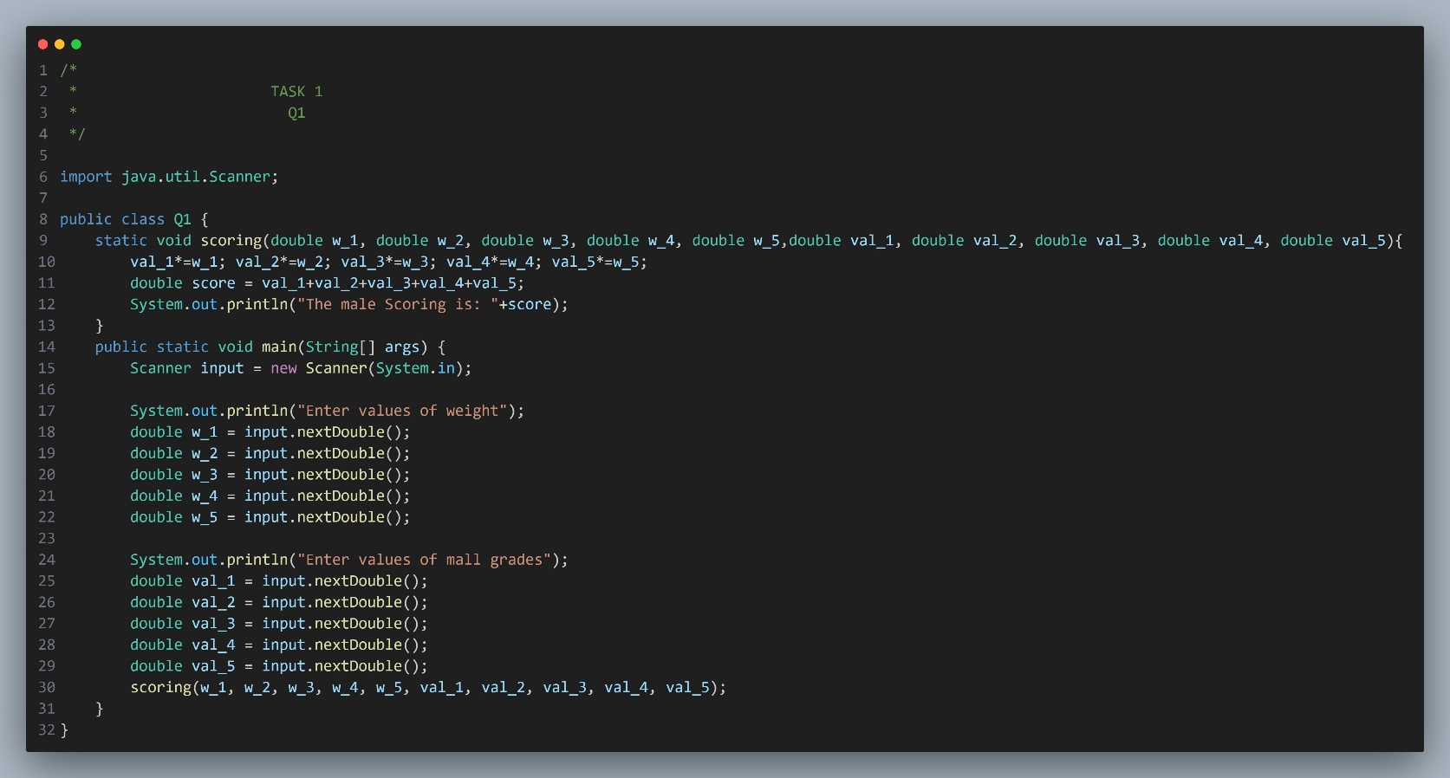

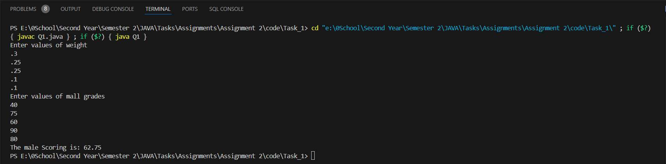

**2. Apply the one-dimensional array named weight [ ] to store the weight of decision criteria.**

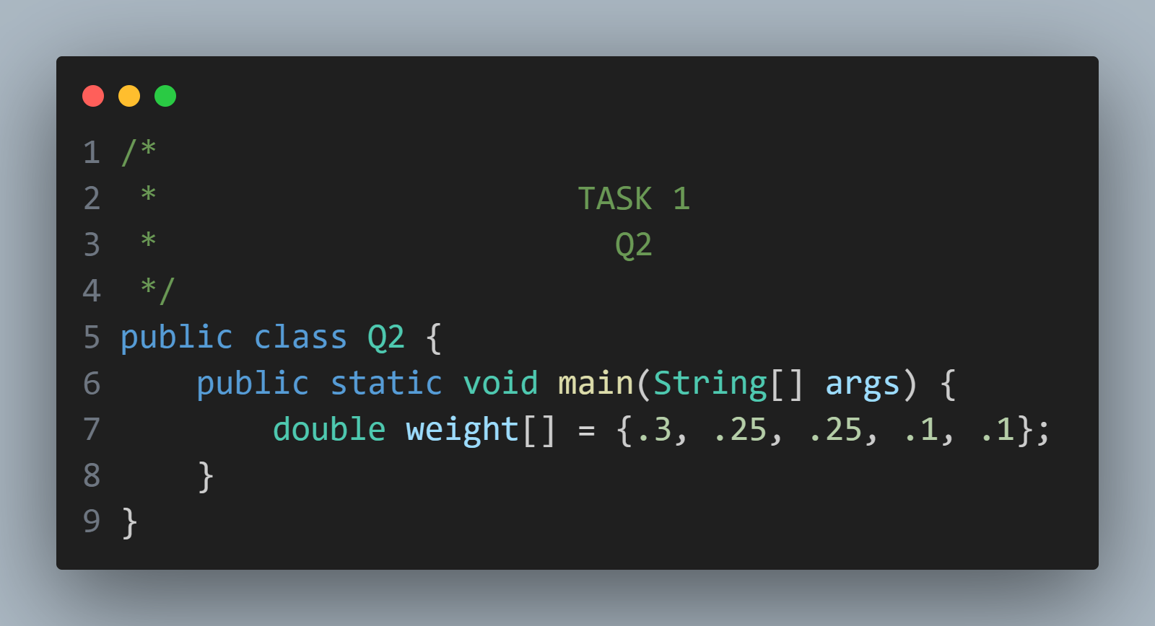

**3. Apply a multidimensional array named grades-of-all malls [ ] to store the related data of all malls in the above Scenario.**

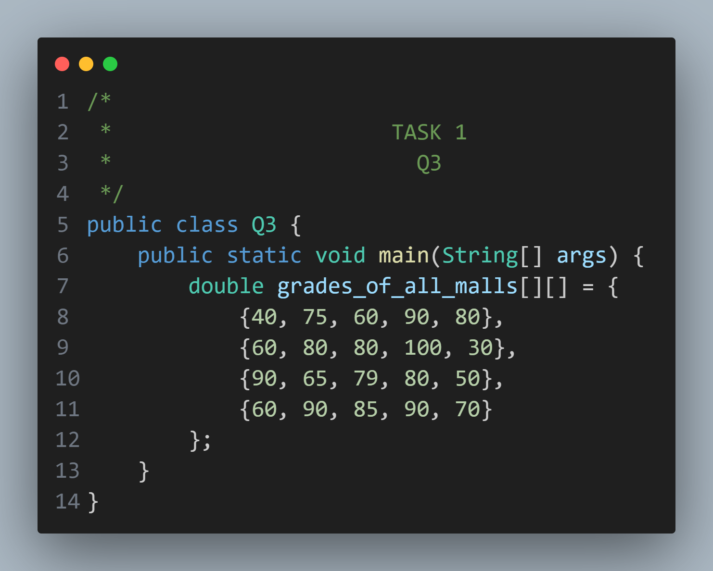

**4. Integrate between the one-dimensional array in 2 and the multidimensional array in 3 with an improved scoring method ( ) that was created in 1.**

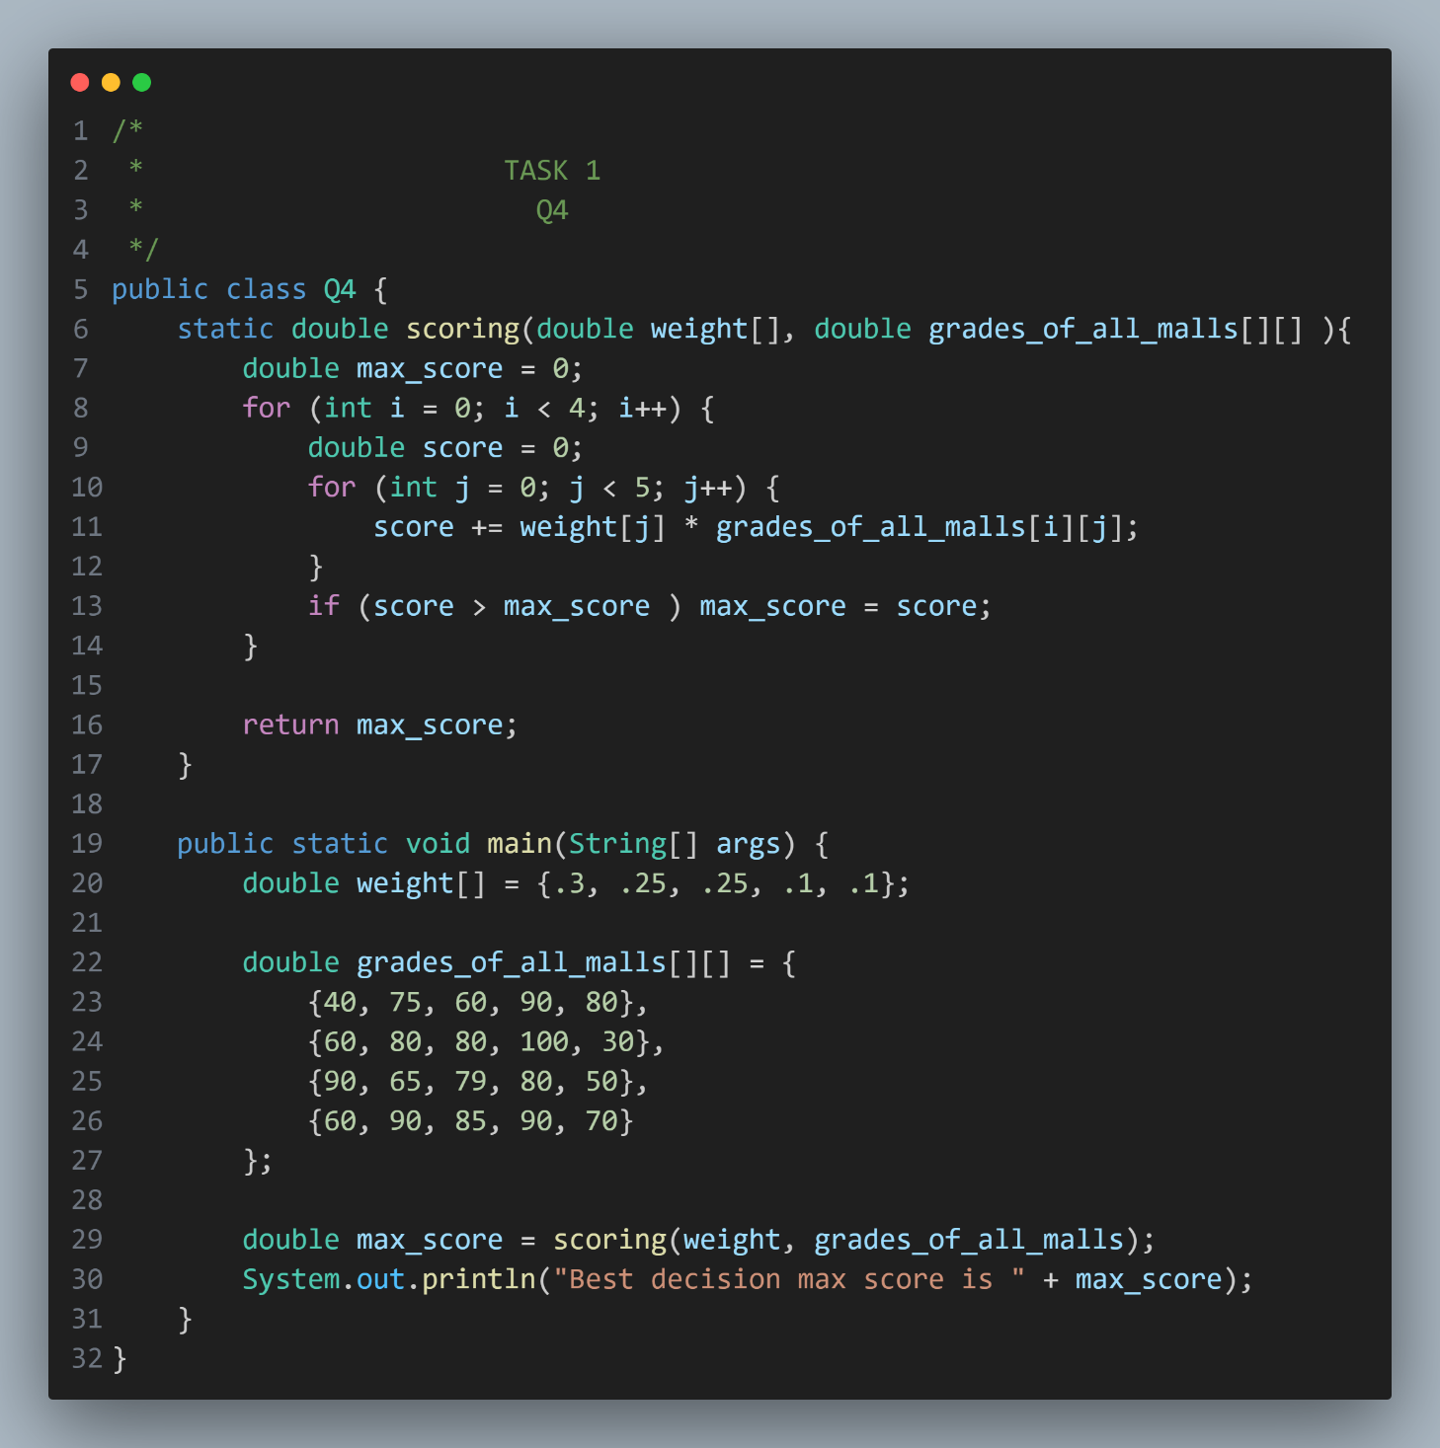



**Task 2**

**1. Create a class named best decision, Execute a constructor in this class to take the weight of decision criteria and the grades of alternatives. Also, this class includes a score method to calculate the score of each alternative and select the best decision**

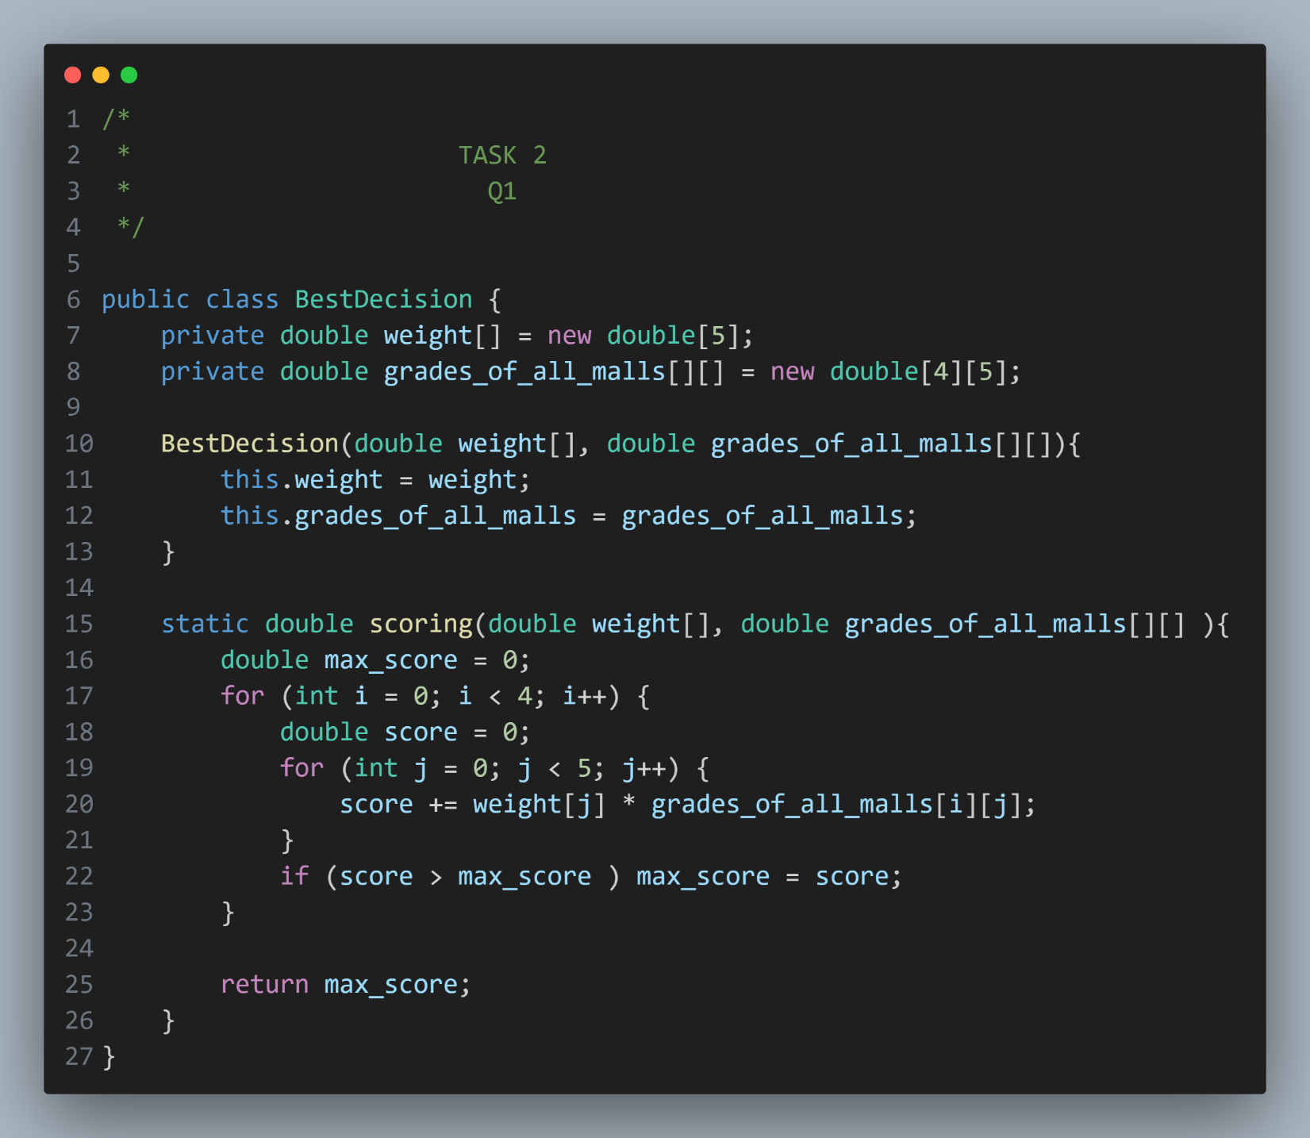

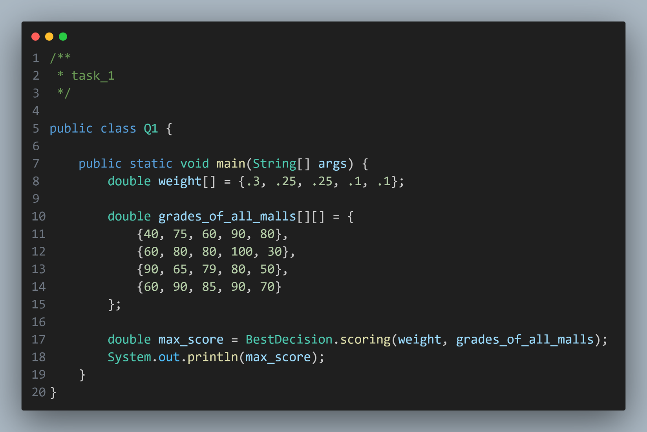

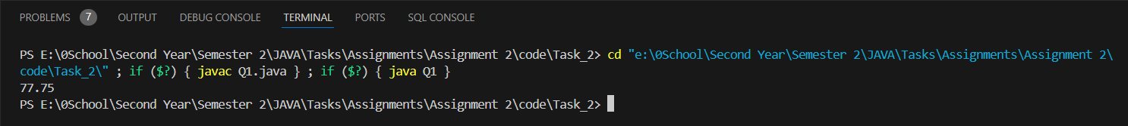

**2. Implement a Java built-in method to find the length of the weight array that is used in the number (Task 1-2)**

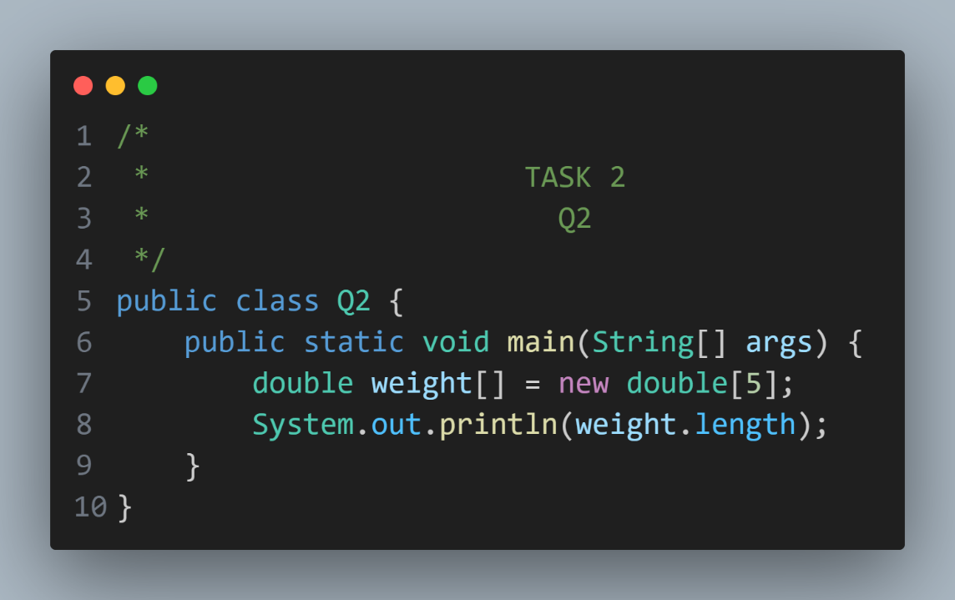

**3. Create an object named Decision-A from the above created class in 2.**

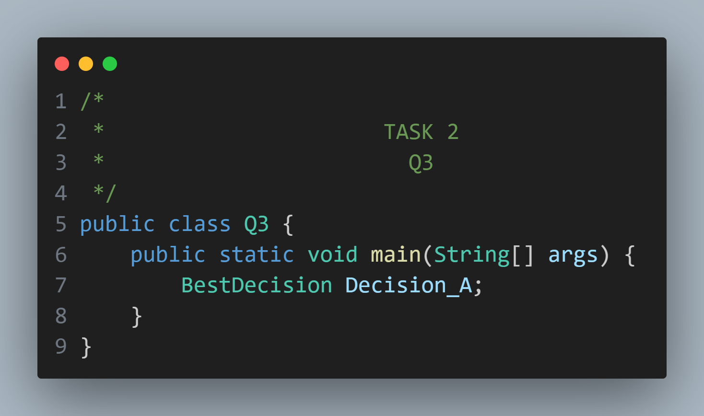

**4. Create an array of objects from the created class in 2. This array of objects named decisions (length of array = 5)**

